Camera surveillance unit assessment application

## Notes for applicant

All rank or hail passenger transport vehicles (PTVs) (taxis) operated in the Perth metropolitan area are required to have a suitable type of camera surveillance unit (CSU) installed and operating.

To assist industry to identify CSU devices which are capable of meeting the required standard the Department of Transport (DoT) publishes a list of suitable devices which have been assessed against the required standard.

In submitting this application, you are requesting that DoT assess your device. If it is assessed as suitable for use the device details will be published on the DoT website in a list of suitable devices.

Completion of this application does not guarantee publication of the device on DoT’s list of suitable devices.

## Application process

Complete this application in full. Refer to the current camera surveillance unit Standards when completing this application:  
[www.transport.wa.gov.au/cameras](http://www.transport.wa.gov.au/cameras)

With the exception of devices which are already approved in other Australian States and Territories for use in taxis, all applications must be accompanied by a sample unit of the device being submitted for assessment. This unit must be provided set up to reflect the way it will operate when installed in a taxi, and be:

* able to record and download footage through DoT’s network;
* provided with a 240 volt to 12 volt step down transformer. This transformer will need to be tagged and tested.

The device will be tested, including but not limited to:

* operating the camera for a minimum of 288 hours;
* operating in low light conditions;
* testing tamperproof capability; and
* testing encryption other security features

# Part 1: Applicant details

|  |  |  |
| --- | --- | --- |
| Applicant |  | |
| Contact person |  | Phone |
| Email |
| Contact address |  | |
| Name of device |  | |
| Model number/s |  | |
| Manufacturer of device  (if different from applicant) |  | |
| Description of device and list of components subject to this application |  | |

# Part 2: Response to Standards

The following table addressing the requirements of a camera surveillance unit must be completed in full. Refer to the Standards published on the DoT website for full details.

| **#** | **Criteria** | **Description of compliance** | **List supporting materials** |
| --- | --- | --- | --- |
|  |  | *Describe how the system meets the requirements* | *List any documents/materials provided that demonstrate compliance with the requirement and include where in those documents the detail can be found.* |
| 2.1 | The CSU must be able to operate in a:  a) temperature range of -5°C to +60°C; and  b) humidity range of 0 to 85 per cent relative humidity, non-condensing. |  | Include certifications. |
| 2.2 | The CSU must be impact and shock resistant to a level sufficient to withstand the vibration experienced during the normal operation of the PTV it is installed in. |  |  |
| 2.3 | Visual and audiovisual recordings from the CSU must be capable of being recovered following loss of power to the CSU. |  |  |
| 3.1 | Device, design, construction and installation must ensure normal operation of the CSU allowing for voltage variants between 8VDC – 18VDC. |  | Include certifications. |
| 3.2 | Device design, construction and installation must ensure that the CSU:  a) will not adversely affect the operation of other systems and devices found in a PTV; and  b) is not adversely affected by other systems and devices found in a PTV, for example electromagnetic interference. |  | Include certifications. |
| 3.3 | The CSU must be powered, fully operational, recording and storing sounds, images and metadata within 30 seconds from the time the vehicle’s ignition is on. |  |  |
| 3.4 | The CSU must have a self-checking function with system status indicators that are clearly visible to the driver when in their normal seated position. Self-check functions must include:  a) confirmation that the device is operating;  b) confirmation that the device is recording; and  c) indication of any system faults. |  |  |
| 3.5 | The CSU must be designed, configured and installed so it logs all:  a) faults;  b) times the CSU has been accessed;  c) software updates; and  d) visual and audiovisual downloads; and  keeps these records for a minimum of 288 hours. |  | Provide sample logs. |
| 3.6 | The CSU must record continuously during the normal operation of the vehicle and store audio recordings, visual recordings and metadata for a minimum of 288 hours. |  |  |
| 3.7 | The CSU must be designed, configured and installed such that no person is able to turn it off or in any way disable the system. |  |  |
| 3.8 | There must be a tamper-proof power connection to the system. |  |  |
| 4.1 | The CSU must be fixed securely in position such that the Cameras (other than a Camera fitted to the exterior of a vehicle):  a) will be visible to passengers in the vehicle who wish to view them; and  b) will record a clear view of the driver and all passengers when seated in the vehicle, including their entire upper body from the waist to the top of the head. |  |  |
| 5.1 | The CSU must be capable of recording a minimum of 5 frames per second for each camera head that forms part of the CSU and set to record at that rate or more. |  | Provide sample recordings. |
| 5.2 | The resolution and clarity of the recorded images from a Camera must be maintained under lighting conditions from darkness (0 lux) through to sunlight (50,000 lux). |  |  |
| 5.3 | Every:  a) visual recording or audiovisual recording;  b) copy of a visual or audiovisual recording; and  c) any print-out or reproduction of a recording  taken by the CSU must display on it the following metadata (without obstructing the image of any occupant in a seated position in the vehicle):  i) the vehicle registration number and vehicle identification number;  ii) date and time in Australian Western Standard Time within one second; and  iii) location in coordinates of latitude and longitude accurate to within 25 metres 95 per cent of the time. |  | Provide sample recordings and print outs showing metadata. |
| 5.4 | The CSU, when recording, must meet the requirements of the Australia New Zealand Policing Advisory Agency’s Australia and New Zealand Police Recommendations for CCTV Systems on facial recognition (images to a facial identification quality of 120%) for CCTV Systems. A copy of these recommendations can be found at www.anzpaa.org.au and include a test chart (second last page) which should be used to establish compliance with this requirement. |  | Provide sample recordings which include the ANZPAA test sheets to demonstrate compliance. |
| 6.1 | The CSU must clearly record, and store the recording of, all voices within the interior of the vehicle during normal operation of the vehicle. For clarity, this requirement shall not be read as requiring audio recording separately from audio visual recording. |  | Provide sample recordings. |
| 7.1 | The recording system for the CSU must be configured so that the recording medium automatically commences re-recording when the medium has reached its recording capacity. The oldest recordings must be overwritten first. For clarity, the recording capacity must, in any event, be sufficient to comply with clauses 3.5 and 3.6 of this Standard. |  |  |
| 8.1 | If the CSU stores visual recordings remotely: a) the remote storage function must include an automated encrypted transmission; and b) visual recordings must be retained in the CSU until confirmation has been received by the CSU that the transmitted images have been received at the remote location. |  |  |
| 8.2 | Access to CSU software and visual recordings, regardless of where they are stored, must be password protected so that the visual recordings cannot be accessed, edited, viewed, downloaded, copied, deleted, printed or otherwise reproduced by an Unauthorised Person. |  |  |
| 8.3 | If the CSU has removable memory, it must only be accessible by an Authorised Person. Anti-tamper protection devices may be used. |  |  |
| 8.4 | Audio recordings must be retained and secured in the same manner as visual recordings. In the context of an audio recording, a reference in these Standards to the viewing of a visual recording shall be read as listening to the audio recording. |  |  |

## Additional considerations

| **#** | **Criteria** | **Description of compliance** | **List supporting materials** |
| --- | --- | --- | --- |
|  | **Training materials and support**  Provide details of training and support that will be provided to persons purchasing the device |  |  |
|  | **Manuals**  Provide details of the user manuals and support materials available to users of the device. |  |  |
|  | **Supplier**  Provide details of where, how and who will supply the devices including installation and maintenance |  |  |
|  | **Vehicle safety standards approval of vehicle modification**  In addition to this assessment any approved device must also comply with rules for Vehicle modifications.  These rules and details on how to obtain an approval can be found at  <https://www.transport.wa.gov.au/licensing/modify-or-construct-a-vehicle.asp>  Please provide details of approvals for the devices to be installed as a vehicle modification. |  |  |
|  | **Approval in other jurisdictions**  If the submitted camera is approved for use in any other Australian jurisdictions, please provide evidence. |  |  |
|  | **Further supporting information** |  |  |

# Part 3: Attachments

Complete the following list of supporting documents. Add additional details where needed. Some documents have been listed to assist applicants to identify documents that should be included in the application.

|  |  |
| --- | --- |
| **Document Name** | **Description** |
| Installation manual/s. |  |
| User manual/s for drivers. |  |
| User manual/s for on-demand booking services (how to access and download recordings). |  |
| Technical specifications. |  |
| Error guide for drivers. |  |
| Copy of sample interior and exterior notice to advice passengers they are being recorded. |  |
| Camera approval from interstate authority. |  |
| Copy of approvals for use in taxis in other Australia States and Territories. |  |
| Additional documents to support this application. |  |

# Part 4: Checklist

Please review the following checklist to ensure that you have provided all of the required materials prior to submitting your application.

A Sample device has been provided with the application that:

* is setup to operate as detailed in the application;
* is able to record and download footage through DoT’s network;
* includes any software and hardware required to download and view recordings on and from the device; and
* includes a 240 volt to 12 volt step down transformer which is tagged and tested.

Note: A sample device is not required for any application where the device is already approved in another state or territory but may be requested if needed.

Part 1: Applicant Details, has been completed in full

Part 2: Response to Standards, has been completed in full

Part 3: Attachments, has been completed in full and all listed attachments are included.

Part 5: Declaration, has been completed

Sample recordings from the device evidencing sounds and vision quality in low and high light conditions are included with the application.

# Part 5: Declaration

|  |  |  |  |  |  |  |
| --- | --- | --- | --- | --- | --- | --- |
| I |  | | representing |  | | hereby submit the following application. |
| We certify that the information provided above is true and correct and is not a misrepresentation of device supplied. If it is found as a misrepresentation of the device supplied the application may be rejected on this basis. | | | | | | |
| Signature | |  | | |
| Position | |  | | |
| Date | |  | | |

# Appendix 1: Seating chart

All seated passengers must be recorded as shown below. Additional cameras may be required to cover rear passengers for vans. The diagram below depicts where the camera is to capture. Add extra cameras if required.

**Figure 1.** Depiction of area to be captured by camera recording.

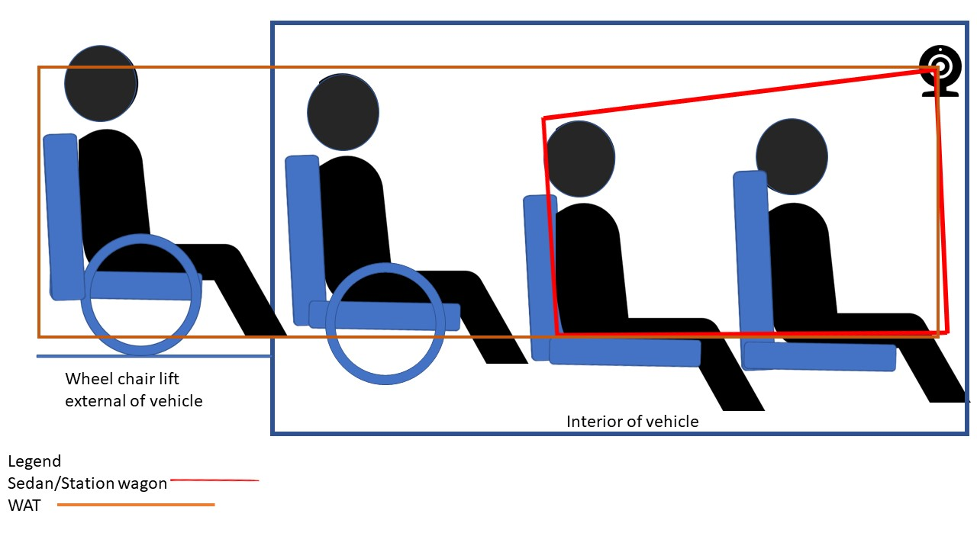

Below is a diagram of a front on view of a passenger seated in the vehicle. As per the previous diagram, the colours represent the capture are depending on the type of vehicle the camera is installed in. Coverage should match or better the diagram above.

**Figure 2.** Front view of image capture area, including wheel chair passengers.

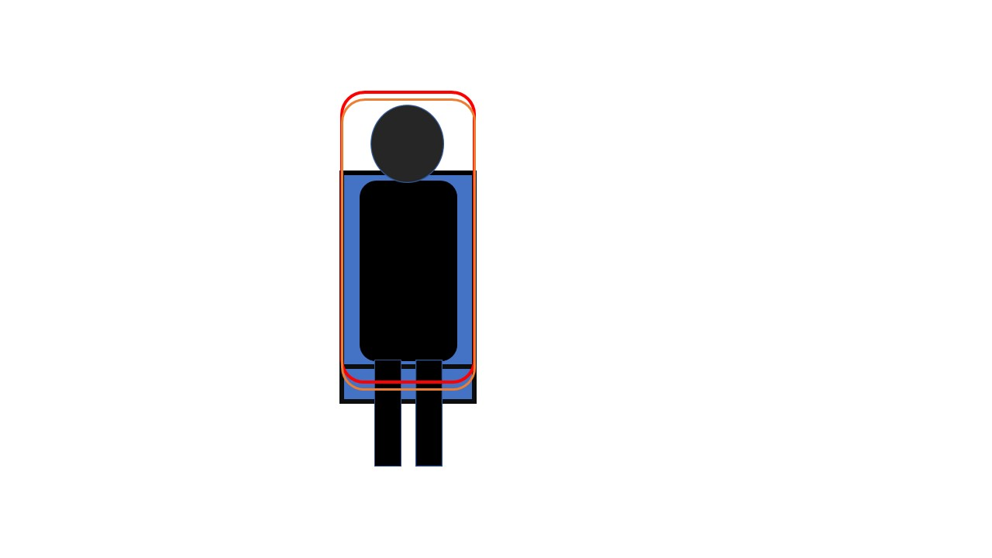

# Office use only

## Camera assessment and notes

| **Criteria** | **Assessment** | **Pass** | **Fail** | **Further information required** |
| --- | --- | --- | --- | --- |
| 2.1 |  |  |  |  |
| 2.2 |  |  |  |  |
| 2.3 |  |  |  |  |
| 3.1 |  |  |  |  |
| 3.2 |  |  |  |  |
| 3.3 |  |  |  |  |
| 3.4 |  |  |  |  |
| 3.5 |  |  |  |  |
| 3.6 |  |  |  |  |
| 3.7 |  |  |  |  |
| 3.8 |  |  |  |  |
| 4.1 |  |  |  |  |
| 5.1 |  |  |  |  |
| 5.2 |  |  |  |  |
| 5.3 |  |  |  |  |
| 5.4 |  |  |  |  |
| 6.1 |  |  |  |  |
| 7.1 |  |  |  |  |
| 8.1 |  |  |  |  |
| 8.2 |  |  |  |  |
| 8.3 |  |  |  |  |
| 8.4 |  |  |  |  |

|  |  |  |  |  |
| --- | --- | --- | --- | --- |
| **Assessment** | **Notes** | **Pass** | **Fail** | **Signature** |
| **Assessor** |  |  |  |  |
| **Manager Safety Assurance** |  |  |  |  |
| **Executive Director On-Demand Transport** |  |  |  |  |